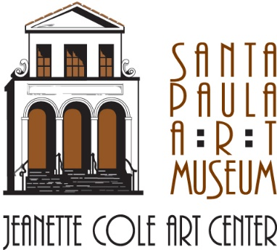
Santa Paula Art Museum
www.santapaulaartmuseum.org

Entries and questions should be submitted to:
Jennifer Heighton or Julie Cluster, Santa Paula Art Museum
117 N. 10th Street / Santa Paula, CA 93060
805.525.5554 / info@santapaulaartmuseum.org

CALL TO ARTISTS

The Land of Light: Art, Science and Play

A free, interactive community event where art, science and play intersect. This one-day event will be held on Saturday, October 6, 2018, from 5:00pm to 9:00pm

Art will be on exhibit inside the Santa Paula Art Museum’s newly renovated Cole Creativity Center and in outdoor spaces around the entire Museum campus. Please see photographs of the event site at the end of this document.

Location: 123 N. 10th Street and 117 N. 10th Street, Santa Paula, California, 93060

www.santapaulaartmuseum.org

About the Santa Paula Art Museum

The Santa Paula Art Museum opened in 2010 as a non-profit organization with a mission to preserve and share Santa Paula, California's artistic heritage including the famous Santa Paula Art Collection; and to educate and engage the community through collection, exhibition, interpretation, programming and outreach. The Museum’s main exhibition building, the Jeanette Cole Art Center, is located in the historic Limoneira Building at 117 N. 10th Street in downtown Santa Paula. In summer 2018, the Museum will expand to include a second building, the newly renovated Cole Creativity Center, located next-door at 123 N. 10th Street. The Cole Creativity Center is a shared space where creativity is abundant, artists share and inspire, students discover and explore, and art builds community. It will offer a wide variety of creative educational programming for children, teens and adults.
About The Land of Light Event

Now in its second year, The Land of Light event at the Santa Paula Art Museum invites visitors to see and experience art in a whole new way. The Land of Light is an event inspired by artists of all ages and designed to engage the community through interactive art installations including (but not limited to) lighting effects, visual film graphics, and displays of science and technology. All of these elements come together in a way that inspires play. Admission to the event is free for everyone.

The Land of Light one-day event sees the entire Santa Paula Art Museum campus transformed as it encompasses multiple spaces and spans from day to night (5:00pm to 9:00pm). The event inhabits the interior of the Santa Paula Art Museum’s newly renovated Cole Creativity Center (opening summer 2018) and outdoor spaces around the entire Museum campus. At sunset, a special “lighting ceremony” activates light and video projections, which illuminate the variety of exhibitions on display. Exhibits range from two-dimensional works to three-dimensional sculptures, “art cars,” robotics, and more. Indoor and outdoor spaces also feature “maker stations” where guests are encouraged to interact with and add to the various artworks and displays. Bilingual signage provides information in each space.

The Land of Light is a part of the Santa Paula Art Museum’s larger community outreach program. The event is the culmination of many months of collaboration between numerous professional artists, local youth artists, and Museum staff. The Land of Light also embraces the spirit of the Museum’s future Cole Creativity Center, which will offer year-round creative classes and programs for both children and adults, all of which aim to strengthen our community through shared experiences in the arts.

Eligibility and Specifications

The Land of Light is open to artists of all ages. This includes schools and individual classrooms, youth organizations and clubs, college students, and professional artists. Artists and groups may also partner with other artists or groups on a specific project. All styles of work and media will be considered. The Land of Light is most actively seeking submissions of free-standing, interactive art installations and/or art-making stations that incorporate the ideas of art, science and play. Submissions should include some type of lighting component. Light can be electric (but installations must power themselves), glow-in-the-dark, reflective, etc. Projects should also be site-specific and should include a participatory aspect; for instance, an element of the installation that is created or activated onsite during the event.

*Please note that hanging space is limited and will be awarded on a first come, first served basis. If an installation includes an electric lighting component, it must be equipped to power itself as electricity cannot be provided. Installations should also be built to withstand heavy traffic in an open area.

Entry Requirements

1) A detailed description and digital image(s) or illustration(s) of your art installation and/or art-making station

Acceptance of your project for inclusion in The Land of Light event will be decided from your description and digital image(s) emailed as attachments to the Santa Paula Art Museum at info@santapaulaartmuseum.org or sent by mail on a CD to 117 N. 10th St., Santa Paula, CA 93060. Alternatively, if your installation is not in a state in which it can be photographed, please send illustrations or plans that will help us to visualize your completed project.

*Your description must be in Microsoft Word format (.doc or .docx). Images should be formatted at 300 pixels per inch at about 4x5 inches, 8 bit, jpg (this size reproduces best for publicity purposes). Please include the artist or organization’s name and the art installation title in each image’s file name (e.g., Jane Smith, Title.jpg). If your files are too large for email, please use a service like Dropbox. Please contact the Museum at (805) 525-5554 if you have any questions about file formatting.

Your detailed description and image(s) or illustration(s) must be received by Monday, July 2, 2018.

2) A completed entry form e-mailed as an attachment or sent by mail (the entry form can be found at the end of this document).

Your entry form must be received by Monday, July 2, 2018.

3) An artist’s resume and/or a statement about your organization

*Resumes and statements must be in Microsoft Word format (.doc or .docx).

Your resume and/or organization’s statement must be received by Monday, July 2, 2018.
Jurors

Submissions will be reviewed and accepted by a panel of The Land of Light curatorial staff. Artists will be notified of whether they’ve been accepted by Monday, July 16, 2018, in order to provide ample time for any projects that require lengthy development.

Use of Art for Publicity

Submission of a digital image by an artist or organization constitutes agreement for the Santa Paula Art Museum to reproduce that image for publicity, website, and educational purposes unless otherwise specified by the artist.

Liability

The Museum exercises the same care and respect to temporary art loans and installations as it does in the safekeeping of its own property. The artwork will be insured under the Santa Paula Art Museum’s policy with AXA Insurance Co., 3 West 35th Street, 11th Floor, New York, NY, 10001, phone: (212) 415-8400. The lender will be named as an additional named insured under this policy.

Delivery and Return of Art

The artist is responsible for delivering their art to the Santa Paula Art Museum before the event and taking it off site after the event. Participants will have the opportunity to install their artworks in the week leading up to the event, and to de-install their artworks during the week following the event. Specific arrangements will be made between the Museum and each individual artist/organization depending on the size and placement of each individual art installation and/or art-making station.

Calendar of Important Dates

Entry Form, Installation Description, Digital Images/Illustrations, and Artist’s Resume/Organization’s Statement Due by Monday, July 2, 2018

Notification of Acceptance Will Be Delivered to Artists/Organizations by Monday, July 16, 2018

Installation Dates: Monday, October 1, 2018, through Friday, October 5, 2018, between the hours of 10:00am to 3:00pm. If your work is accepted, the Museum will make specific arrangements with you as to the date and time of your installation.

Event Date: Saturday, October 6, 2018, from 5:00pm to 9:00pm

De-Installation Dates: Monday, October 8, 2018 through Friday, October 12, 2018, between the hours of 10:00am to 3:00pm. The Museum will make specific arrangements with you as to the date and time of your de-installation.

For more information, please contact Jennifer Heighton or Julie Cluster
at the Santa Paula Art Museum:
805-525-5554 or info@santapaulaartmuseum.org

To see images from the 2017 The Land of Light event, please visit:
https://www.santapaulaartmuseum.org/landoflight

The Land Of Light Entry Form

Please complete the following page and return by it e-mail along with your description, images/illustrations, and resume/statement. Alternatively, you may mail your entry form and other materials to 117 N. 10th Street, Santa Paula, CA 93060.

Entrant Information (please print)

Artist or Organization’s Name*____________________________________________________________

Contact Person for Organization__________________________________________________________

Phone___________________________________ E-mail___________________________________________

Address____________________________________________________________________________________

City___________________________________________ State_____________ Zip_____________________

Website____________________________________________________________________________________

*Please note that the name you provide us with here will be used to refer to you in all event publicity materials.

Artist’s Entry:

Title_______________________________________________________________________________________

Medium/Material_________________________________________________________________________

Size (can be approximated)_______________________________________________________________

Photographs of the Event Site

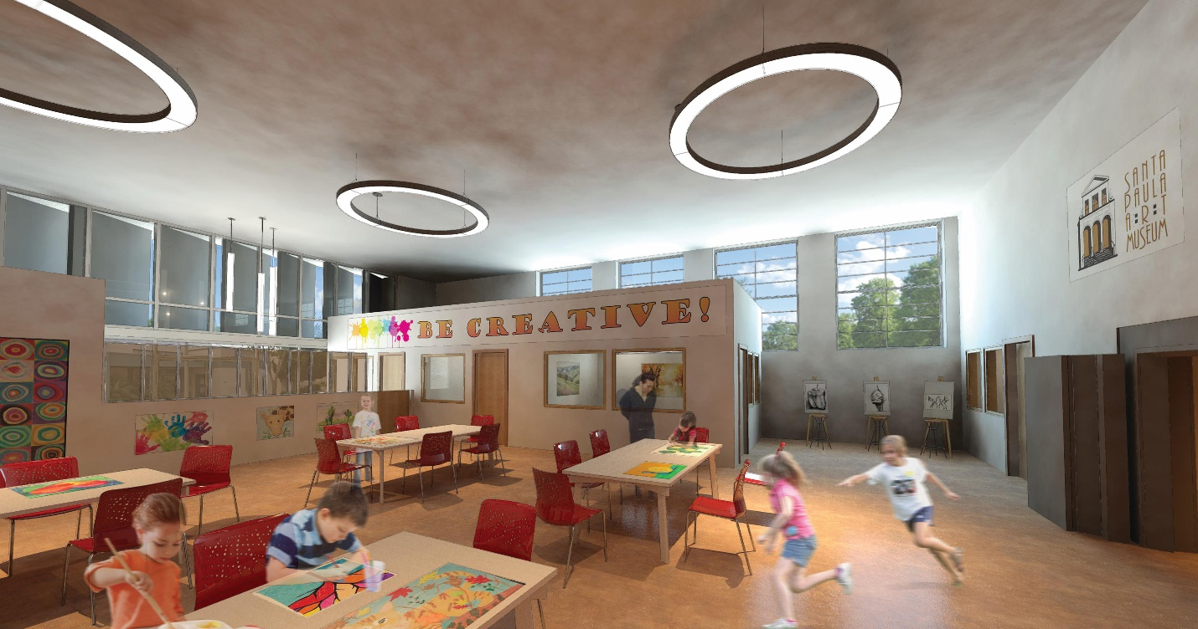

An artist’s rendering of the interior of the Cole Creativity Center, the renovation of which will be completed in summer 2018. The main “Creativity Space” that you see here is roughly 1,200 sq ft. Ceilings are 17 feet high. Hanging space is available but limited, and will be awarded on a first come, first served basis.

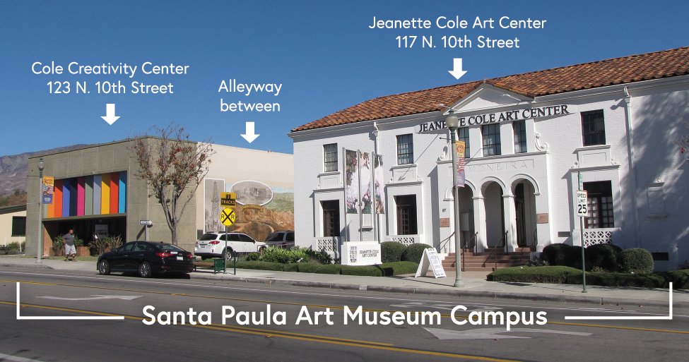

The Land of Light event encompasses multiple spaces within the Santa Paula Art Museum campus including the interior of the Cole Creativity Center, an outdoor alley, and an outdoor lot.

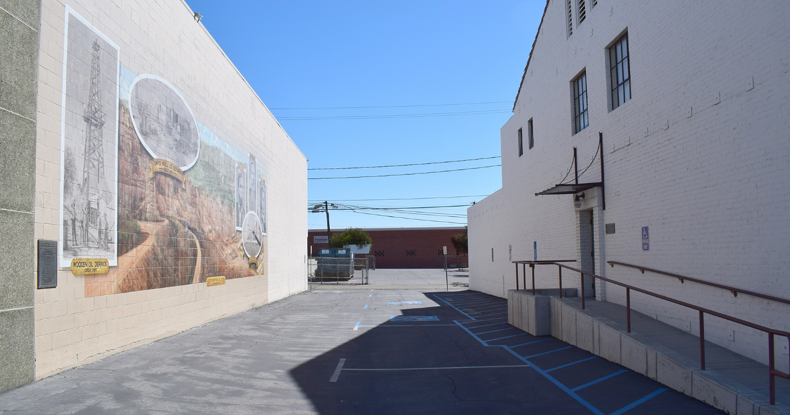

The alleyway between the Santa Paula Art Museum’s Cole Creativity Center (on left) and Jeanette Cole Art Center (on right) leads to a back lot (below).

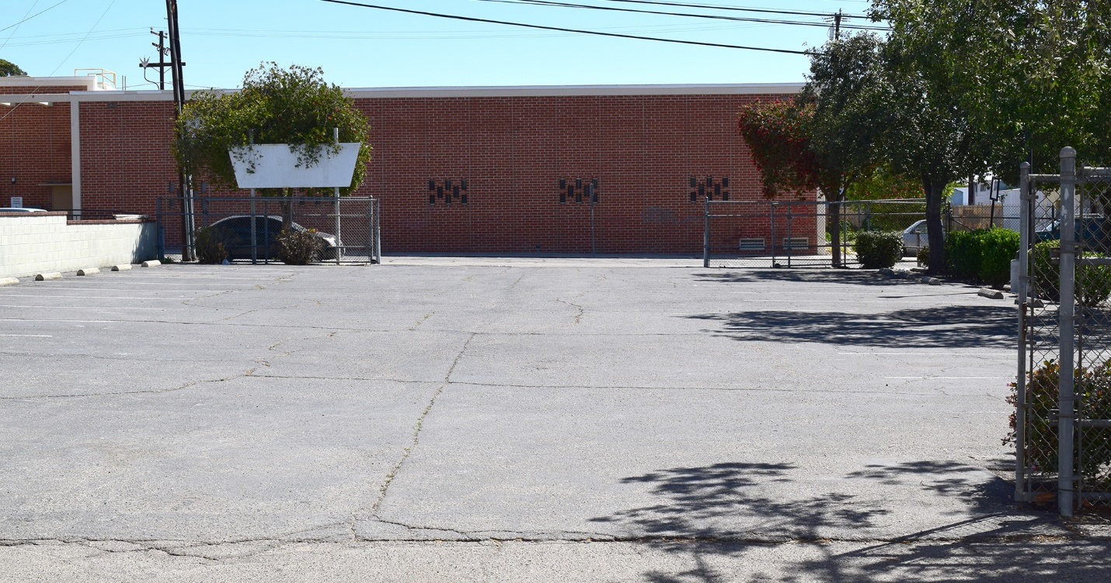

The back lot behind the Santa Paula Art Museum campus.

